2019 Florida Court Interpreter Conference Agenda APP
Via Crowd Compass Attendee APP
Please use this APP to access and reference conference materials.
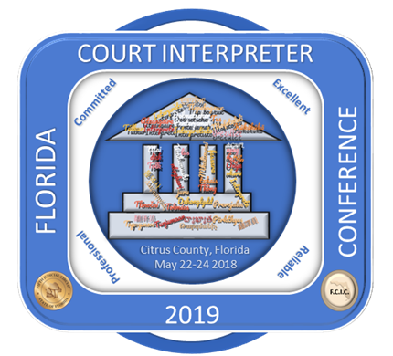
- Click on APP link: https://event.crowdcompass.com/2019courtinterpreter/feeds/all
- Download on the APP store
Google APP Store link:
https://play.google.com/store/apps/details?id=com.crowdcompass.app4815162342&hl=en
Apple APP Store:
https://itunes.apple.com/us/app/crowdcompass-attendeehub/id604224729
- Down load Crowd Compass Attendee Hub.
- Open Crowd Compass Attendee Hub. The below screen will appear.

In the search field type, interpreter (shown below) and press the search key.

It will find the 2019 Florida Court Interpreter Conference. Touch Download.

Once downloaded, enter your name and select Next (shown below).
.

CrowdCompass will send you an email with a verification code.

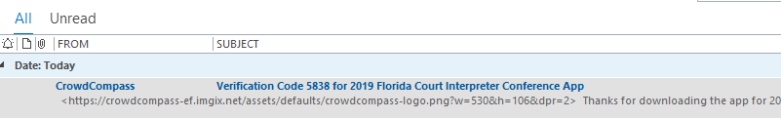

Enter the code in the CrowdCompass app and you will be signed in!

