FIFTH JUDICIAL CIRCUIT OF FLORIDA
PARENTING COORDINATOR
RENEWAL APPLICATION

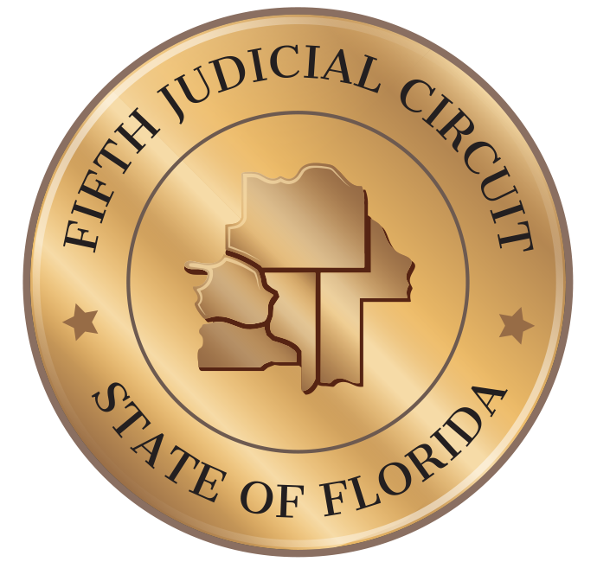

2020-2021

FIFTH JUDICIAL CIRCUIT OF FLORIDA
PARENTING COORDINATOR RENEWAL
INSTRUCTIONS: ANSWER ALL QUESTIONS ACCURATELY, USING DARK INK OR TYPEWRITTEN. PLEASE PRINT CLEARLY.

DATE ________

I, ________________________________________________, DESIRE TO REMAIN ON THE PARENTING COORDINATOR LIST FOR THE FIFTH JUDICIAL CIRCUIT FOR THE 2020-2021 FISCAL YEAR.

PERSONAL INFORMATION PLEASE PROVIDE UPDATED INFORMATION BELOW:

NAME_________________________________________________________________________
(Last) (First) (Middle)

ADDRESS______________________________________________________________________
(Street) (City) (State) (Zip)

TELEPHONE____________________________________________________________________
(Work) (Cellular)

EMAIL ADDRESS ____________________________

PROFESSIONAL INFORMATION

BUSINESS NAME________________________________________________________________

BUSINESS ADDRESS______________________________________________________________
(Street) (City) (State) (Zip)

BUSINESS TELEPHONE____________________________________________________________

BUSINESS EMAIL ADDRESS _________________

LOCATION WHERE SERVICES WILL BE PERFORMED
_____: CIRCUIT WIDE  Initial | _____: CITRUS COUNTY  Initial | _____: HERNANDO COUNTY  Initial
_____: LAKE COUNTY  Initial | _____: MARION COUNTY  Initial | _____: SUMTER COUNTY  Initial

FEE STRUCTURE

WHAT IS YOUR HOURLY RATE AS A PARENTING COORDINATOR? _______________________

DO YOU REQUIRE A RETAINER? ________

IF YES, AMOUNT OF THE RETAINER. ______________________

ARE YOU WILLING TO ACCEPT PRO BONO OR REDUCED FEE APPOINTMENTS? ______________

IF YES, PLEASE SPECIFY CONDITIONS: _____________________

PROFESSIONAL REQUIREMENT
PLEASE SELECT ALL THAT APPLY: PROVIDE A COPY OF LICENSE. IF FAMILY LAW MEDIATION CERTIFICATION IS USED TO FULFILL REQUIREMENT, A COPY OF THE APPLICANT’S MASTERS OR DOCTORATE DEGREE, IN A MENTAL HEALTH FIELD, MUST BE SUBMITTED WITH THIS FORM.

_____ LICENSED MENTAL HEALTH PROFESSIONAL UNDER FLORIDA STATUTES SECTIONS 490 OR
491.
FLORIDA LICENSE NO.: ____________

_____ LICENSED PHYSICIAN UNDER FLORIDA STATUES SECTION CHAPTER 458, WITH
CERTIFICATION BY AMERICAN BOARD OF PSYCHIATRY AND NEUROLOGY,

FLORIDA LICENSE NO.: _____________

_____ FLORIDA SUPREME COURT CERTIFIED FAMILY LAW MEDIATOR WITH AT LEAST A
MASTER’S DEGREE IN A MENTAL HEALTH FIELD,

FLORIDA LICENSE NO.: ________________

______MEMBER IN GOOD STANDING OF THE FLORIDA BAR

FLORIDA BAR NO.: ______________

PLEASE LIST THE CONTINUING EDUCATION UNITS YOU HAVE COMPLETED AS A LICENSED MENTAL HEALTH PROFESSIONAL, LICENSED PHYSICIAN, FLORIDA SUPREME COURT CERTIFIED FAMILY LAW MEDIATOR AND/OR MEMBER OF THE FLORIDA BAR DURING THE PAST THREE YEARS:

ADJUDICATION:

IF YOU ANSWER YES TO ANY OF THE QUESTIONS BELOW, PROVIDE A SEPARATE WRITTEN EXPLANATION AND COPIES OF ALL RELEVANT DOCUMENTATION FOR EACH ITEM.

_____: HAVE YOU BEEN CONVICTED OR HAD AN ADJUDICATION WITHHELD ON A CHARGE OF
CHILD ABUSE, CHILD NEGLECT, DOMESTIC VIOLENCE, PARENTAL KIDNAPPING, OR INTERFERENCE WITH CUSTODY OR TIME-SHARING?

_____: HAVE YOU BEEN FOUND BY A COURT IN A CHILD PROTECTION MATTER TO HAVE
ABUSED, NEGLECTED, OR ABANDONED A CHILD?

_____: HAVE YOU CONSENTED TO AN ADJUDICATION OR A WITHHOLDING OF ADJUDICATION
ON A PETITION OF DEPENDENCY?

_____: HAVE YOU BEEN OR ARE YOU CURRENTLY A RESPONDENT IN A FINAL ORDER OF
INJUNCTION FOR PROTECTION AGAINST DOMESTIC VIOLENCE?

_____: HAVE YOU EVER BEEN FOUND GUILTY OR ADJUDICATED GUILTY OF A CRIME AS AN
ADULT IN FLORIDA OR ANY OTHER STATE?

_____: HAVE YOU HAD AN ADJUDICATION OF GUILT OR JUDGMENT WITHHELD IN FLORIDA OR
ANY OTHER STATE?

ATTESTATION

I SWEAR/AFFIRM THE INFORMATION SUPPLIED ON THIS RENEWAL APPLICATION AND ALL DOCUMENTS PROVIDED IS CORRECT, THAT I REMAIN QUALIFIED TO SERVE AS A PARENTING COORDINATOR AS DEFINED IN SECTION 61.125 OF THE FLORIDA STATUTES.

I CERTIFY THAT I HAVE READ, UNDERSTAND AND AGREE TO ABIDE BY THE FLORIDA RULES FOR PARENTING COORDINATORS AND SECTION 61.125 OF THE FLORIDA STATUTES. I UNDERSTAND ANY OMISSIONS, FALSIFICATIONS, MISSTATEMENTS OR MISREPRESENTATIONS OF THE INFORMATION PROVIDED IN THIS APPLICATION OR INFORMATION REQUIRED TO BE SUBSEQUENTLY PROVIDED MAY BE GROUNDS FOR REMOVAL OF MY NAME FROM THE PARENTING COORDINATOR LIST FOR THE FIFTH JUDICIAL CIRCUIT.

I UNDERSTAND I MUST NOTIFY THE FIFTH JUDICIAL CIRCUIT IN WRITING WITHIN THIRTY (30) DAYS OF ANY CHANGE IN MY CONTACT INFORMATION, LEGAL NAME CHANGE, CHANGE IN FEES, ANY CRIMINAL CONVICTION, ADJUDICATION, WITHHOLDING OF CONVICTION OR ADJUDICATION, ANY DISQUALIFICATION UNDER SECTION 61.125 OF THE FLORIDA STATUTES, OR ANY CHANGE IN THE STATUS OF A PROFESSIONAL LICENSE OR CERTIFICATION WHICH I CURRENTLY HOLD.

MY SIGNATURE REFLECTS MY UNDERSTANDING I AM SIGNING THIS DOCUMENT UNDER PENALTY OF PERJURY.

_________________________________________ ____________
SIGNATURE DATE

___________________________________________
PRINT NAME

MAIL RENEWAL APPLICATION TO:

PETER SPANOS
ALTERNATIVE DISPUTE RESOLUTION DIRECTOR
20 N. MAIN STREET
BROOKSVILLE, FL 34601

OR VIA EMAIL

PSPANOS@CIRCUIT5.ORG

