IN THE CIRCUIT COURT OF THE FIFTH JUDICIAL CIRCUIT
IN AND FOR LAKE COUNTY, FLORIDA

***, CASE NO. ***
Petitioner, DIVISION: BJW

And

***,
Respondent.
/

ORDER AFTER CASE MANAGEMENT CONFERENCE

THIS CAUSE came on for hearing on the ***, for Case Management Conference. The Court being fully advised finds and orders the following:
- The following appeared:
Petitioner ☐in person ☐by phone ☐did not appear ☐ Zoom Video
Petitioner’s Attorney ☐in person ☐by phone ☐did not appear ☐ Zoom Video
Attorney appearing:
Respondent ☐in person ☐by phone ☐did not appear ☐ Zoom Video
Respondent’s Attorney ☐in person ☐by phone ☐did not appear ☐ Zoom Video
Attorney appearing:
2. Case Type: ☐ Dissolution ☐ Modification ☐ Paternity ☐ Contempt/Enforce.
3. Issues remaining:
4. Expected length of trial:
5. Mediation to be set no later than:
6. The matter is scheduled for Trial and is set for ☐ 1-week trial term beginning at 8:30 a.m.
7. Disclosure of Experts: II: Δ:
8. Discovery Cut-Off:
9. Witness Lists: Exhibit Lists:
10. Waiver of records custodians:
☐ applies to experts ☐ does not apply to experts
11. Copies in lieu of originals
12. Other: The parties shall exchange documents by and unless objected to within two (2) weeks, documents are self-authenticated and no records custodian is needed.
13. A Pretrial Conference/Docket Sounding will be held on _ at _________ a.m./p.m., in Courtroom 1F, of the Lake County Judicial Center, 550 West Main Street, Tavares, Florida 32778, before the undersigned Circuit Judge pursuant to Rule 1.200, Florida Rules of Civil Procedure, to consider all matters suggested in this rule to simplify the issues and expedite the trial, or other disposition of the case. Each party be represented at the conference by the attorney who expects to conduct the actual trial of the case, and that such attorney not only be familiar with the provisions and purposes Fla. Fam. L.R.P. 12.200 and F.R.Civ.P. 1.200, but with his own evidence, with full authority to discuss, agree, and stipulate, insofar as possible on all matters of fact and law not in issue which will simplify and expedite the trial. It is further Ordered that:
- The parties to this cause shall be present at the pre-trial conference.

- At least ten (10) days prior to said pre-trial conference, counsel shall e-file, and provide a copy thereof to opposing counsel, a memorandum containing the following:

- A brief memorandum setting forth the general nature of the proceedings, including:

- The names of all parties;
- Factual contentions of each party;
- The type of action and relief sought;
- The defense interposed;
- The type of counterclaim, if any, and the relief sought thereby;

- CHILDREN

Name Date of Birth

Child(ren)’s Health Insurance Monthly Premium: $ Paid by:

Child(ren)’s Monthly Daycare Expense: $ Paid by:

Proposed Child Support: $ (Worksheet MUST be attached)

- CHILDREN TIME SHARING – 28 DAY CALENDAR

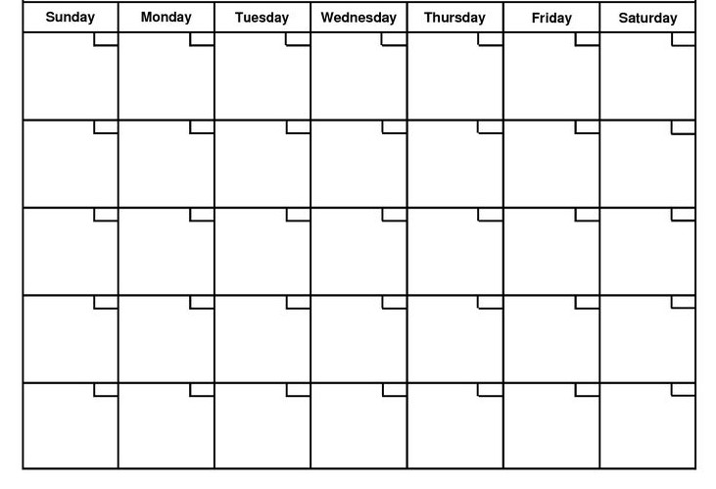
M=Mother
F=Father

F M M M M F F
Summer Proposal:

Holiday Proposal:

Total overnights annually: Mother Father

- A schedule of all exhibits and documentary evidence which may be used at trial;

- Witness list of the names and addresses of all individuals who may be called to testify at the trial; including expert witnesses. No expert shall be permitted to vary testimony from their depositions based on subsequently supplied information or data unless:

- Opposing counsel is advised of the new opinions; and

- The expert is made available for an update deposition prior to trial.

- Any requests for preliminary rulings on questions of law and citations in regard thereto.

- A joint stipulation of all admitted facts. The failure to admit an undisputed fact may result in sanctions against the offending party or attorney.

- Conclude the memorandum by setting forth any request for preliminary rulings on questions of law and citations in regard thereto.

- This conference may be reported at the option and expense of either party.

- Should either party desire the trial of this cause to be reported, it shall be the responsibility of counsel for that party to insure the presence of a qualified reporter for that purpose at the time of trial. Counsel are encouraged to stipulate to designation of a reporter at or prior to the pre-trial conference.

- Counsel are encouraged to stipulate to admissibility of evidence listed in their respective pre-trial memos.

- Prior to the pre-trial conference, counsel shall confer relative to the following:

  - The admissibility of documentary evidence and reservations of objections pertaining only to relevancy and materiality, waiving those relating to authenticity and/or requirements for custodians;

  - Any matter of law or fact about which there is no issue;

  - Any matters that would simplify the issues or aid in the speedy disposition of the action; and

  - Possible settlement.

- Unless extended by order of the court, all discovery shall be completed on or before the pre-trial conference date. Discovery extensions granted due to the parties’ stipulation or agreement shall not form the basis for a continuance of the trial of this matter.

- Failure of any party to appear or to comply with any other provisions of this order will be grounds for the court to strike that party’s pleadings or take such other action as justice requires, including, but not limited to fines and/or incarceration for contempt.

- Failure to timely deliver the pre-trial memorandum at least ten (10) days prior to pre-trial conference may result in the pre-trial being cancelled.

- EXHIBITS

  - Any objection to a listed exhibit shall be raised by motion prior to trial. Failure to do so will result in a waiver of the objection.

  - The failure to list an exhibit shall be grounds for exclusion of that exhibit from evidence.

It is further ORDERED, the attorney of record shall furnish a copy of this Order to each self-represented party by U.S. Mail, first class, postage paid; and, file a certificate of mailing signed by the attorney that delivery of this Order has been made.

If you are a person with a disability who needs any accommodation in order to participate in this proceeding, you are entitled, at no cost to you, to the provision of certain assistance. Please contact the ADA Coordinator at the Office of the Trial Court Administrator, Lake County Courthouse, P.O Box 7800/550 W. Main Street, Tavares, Florida 32778, Telephone (352) 742-4221, at least 7 days before your scheduled court appearance, or immediately upon receiving this notification if the time before the scheduled appearance is less than 7 days; if you are hearing or voice impaired, call 711.

DONE AND ORDERED in Tavares, Lake County, Florida on this ** day of ** 202*.

BRIAN J. WELKE
CIRCUIT JUDGE
CERTIFICATE OF SERVICE

I HEREBY CERTIFY that on this ** day of **, 202*, I electronically filed the foregoing document with the Clerk of Court using the Florida Courts E-Filing Portal. I also certify that the foregoing document is being served this day on all counsel of record and interested parties, via transmission generated by the Florida Courts E-Filing Portal.

Judicial Assistant

EXHIBIT “A”
ASSETS/DEBTS

ASSET/DEBT DESCRIPTION H’S W’S H’S W’S DATE OF HOW PROPOSED
VALUE VALUE DEBT DEBT PURCHASE TITLED DISTRIBUTION
TOTALS | $ | $ | $ | $
(If needed, add additional chart pages)

Total Net Equity to Husband $_________________________

Total Net Equity to Wife $____________________________

