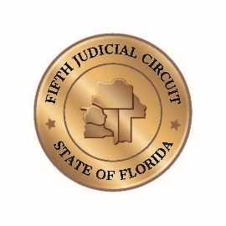

Civil Cases for Circuit Judge Steven G. Rogers

Join Zoom Meetings for Civil Cases for Judge Rogers by using the link below:
https://zoom.us/j/98611458564?pwd=SUsvUHk4bERsMWhob2lCZzQzeElHdz09
Meeting ID: 986 1145 8564
Passcode: 041285

One tap mobile
+17866351003,,98611458564#,,,,*041285# US (Miami)
+14703812552,,98611458564#,,,,*041285# US (Atlanta)
Dial by your location
+1 786 635 1003 US (Miami)
+1 470 381 2552 US (Atlanta)
+1 646 518 9805 US (New York)
+1 646 558 8656 US (New York)
+1 651 372 8299 US (Minnesota)
+1 267 831 0333 US (Philadelphia)
+1 301 715 8592 US (Washington DC)
+1 312 626 6799 US (Chicago)
+1 470 250 9358 US (Atlanta)
+1 669 900 9128 US (San Jose)
+1 720 928 9299 US (Denver)
+1 971 247 1195 US (Portland)
+1 206 337 9723 US (Seattle)
+1 213 338 8477 US (Los Angeles)
+1 253 215 8782 US (Tacoma)
+1 346 248 7799 US (Houston)
+1 602 753 0140 US (Phoenix)
+1 669 219 2599 US (San Jose)
833 548 0276 US Toll-free
833 548 0282 US Toll-free
877 853 5257 US Toll-free
888 475 4499 US Toll-free
Meeting ID: 986 1145 8564
Passcode: 041285
Find your local number: https://zoom.us/u/abcUawd5By

Join by SIP
98611458564@10.212.72.197
10.212.72.197
Meeting ID: 986 1145 8564
Passcode: 041285

